Educational Visits (EVC) Policy
Policy Written/Reviewed by | Lee Ketcher
Date of Review | January 2021
Date of Next Review | January 2023
Approved by Trust Board | 3 March 2021

Context

We believe that educational visits are an integral part of the entitlement of every pupil to an effective and balanced curriculum. Appropriately planned visits are known to enhance learning and improve attainment, and so form a key part of what makes The Rowans a supportive and effective learning environment.

The benefits to pupils of taking part in visits and learning outside the classroom include, but are not limited to:
- Improvements in their ability to cope with change.
- Increased critical curiosity and resilience.
- Opportunities for creativity, developing learning relationships and practicing strategic awareness.
- Increased levels of trust and opportunities to examine the concept of trust (us in them, them in us, them in themselves, them in each other).
- Improved achievement and attainment across a range of curricular subjects. Pupils are active participants not passive consumers, and a wide range of learning styles can flourish.
- Enhanced opportunities for ‘real world’ ‘learning in context’ and the development of the social and emotional aspects of intelligence.
- Increased risk management skills through opportunities for involvement in practical risk-benefit decisions in a range of contexts. ie. encouraging pupils to become more risk aware as opposed to risk averse.
- Greater sense of personal responsibility.
- Possibilities for genuine team working including enhanced communication skills.
- Improved environmental appreciation, knowledge, awareness and understanding of a variety of environments.
- Improved awareness and knowledge of the importance and practices of sustainability.
- Physical skill acquisition and the development of a fit and healthy lifestyle.

Application

Any visit that leaves the school grounds is covered by this policy, whether as part of the curriculum, during school time, or outside the normal school day.

In addition to this Educational Visits Policy, The Rowans

- Adopts the: ‘Guidance for Educational Visits and Related Activities with National Guidance & EVOLVE’ (All staff have access to this via EVOLVE).
- Adopts National Guidance www.oeapng.info, (as recommended by the LA).
- Uses EVOLVE, the web-based planning, notification, approval, monitoring and communication system for off-site activities. Training is available to staff to ensure that they are competent in using Evolve.

All staff are required to plan and execute visits in line with school policy (ie. this document), and National Guidelines. Staff are particularly directed to be familiar with the roles and responsibilities outlined within the guidance.

Types of visit

There are three types of visit:

- Visits/activities within the ‘School Learning Area’ that are part of the normal curriculum and take place during the normal school day.
These follow the ‘School Learning Area’ Operating Procedure (See Appendix 1).

- Day visits within the UK that do not involve an adventurous activity.
These are entered on EVOLVE by the visit leader and submitted to the EVC for checking. The EVC then submits to the Head for approval.

- Visit that are overseas, and/or residential, and/or involve an adventurous activity.
These follow 2. above, but the Head then submits the visit to the Health and Safety Advisor for approval.

Roles and responsibilities
Visit leaders are responsible for the planning of their visits, and for entering these on EVOLVE (where required). They should obtain outline permission for a visit from the Head Teacher prior to planning, and certainly before making any commitments. Visit leaders have responsibility for ensuring that their visits will comply with all relevant guidance and requirements and should seek advice from the EVC where necessary. Visit leaders are responsible for following the correct protocol at all times.
Visit Leaders are also responsible for evaluating each trip once it is completed.

The Educational Visits Coordinator (EVC) is Lee Ketcher, who will support and challenge colleagues over visits and learning outside the classroom (LOtC) activities. The EVC is the first point of contact for advice on visit related matters, and will check final visit plans on EVOLVE before submitting them to the Head. The EVC sets up and manages the staff accounts on EVOLVE, and uploads generic school documents, etc. The EVC also delivers training to staff about visits and Evolve.

The Head Teacher has responsibility for authorising all visits and for submitting all overseas, residential or adventurous activity visits to the LA for approval, via EVOLVE.

The Trustee’s role is that of a ‘critical friend’ and individual members may request ‘read-only’ access to EVOLVE.

The Health and Safety Advisor is responsible (via an SLA with the Academy) for the final approval (via EVOLVE) of all visits that are either overseas, residential, and/or involve an adventurous activity.

Staff Competence

We recognise that staff competence is the single most important factor in the safe management of visits, and so we support staff in developing their competence in the following ways:
- An apprenticeship system, where staff new to visits assist and work alongside experienced visit leaders before taking on a leadership role.
- Supervision by senior staff on some educational visits.
- Support for staff to attend training courses relevant to their role, where necessary.

In deciding whether a member of staff is competent to be a visit leader, the Head Teacher and EVC will take into account the following factors:
- Relevant experience.
- Previous relevant training.
- The prospective leader’s ability to make dynamic risk management judgements, and take charge in the event of an emergency.
- Knowledge of the pupils, the venue, and the activities to be undertaken.

Approval

The approval process is as follows for each type of visit:

- Local visits follow the ‘Extending learning locality’ policy (Appendix 1).
- Day visits within the UK that do not involve an adventurous activity. These are entered on EVOLVE, and must be submitted to the EVC for checking at least 10 days in advance, and then forwarded to the Head for approval.
- Visits that are overseas, residential, and/or involve an adventurous activity (see LA guidance for definition of ‘adventurous’) are then submitted by the Head to the Health and Safety Advsior for approval. These types of visits need to be entered into Evolve four weeks before a visit.

Emergency procedures

A critical incident is any incident where events go beyond the normal coping mechanisms and experience of the visit leadership team.

The school has an emergency plan in place to deal with a critical incident during a visit (see Appendix 2). All staff on visits are familiar with this plan and it is tested at least bi-annually and following any major staffing changes.

When an incident overwhelms the establishment’s emergency response capability, or where it involves serious injury or fatality, or where it is likely to attract media attention then assistance will be sought from the local authority.

Educational Visits Checklist

The Rowans’ Educational Visits Checklist forms part of the risk management process for visits and off-site activities. . A visit should only go ahead if the answer to all relevant questions is ‘YES’. The Rowans’ Educational Visits Checklist may be downloaded from EVOLVE Resources.

Parental Consent
Consent is not required for activities within the School Learning Area that are part of the normal curriculum during normal school time.

The school obtains blanket consent at the start of each year for activities that fall within the ‘Extended learning locality’ (see Appendix 1) and for those which fall within the usual school day curriculum. Eg. after school fixtures.

Specific, (ie. one-off), parental consent must be obtained for all other visits, through a traditional paper consent form. For these visits, sufficient information must be made available to parents (via EVOLVE, letters, meetings, etc), so that consent is given on a ‘fully informed’ basis.

All pupils and parents must sign The Rowans trips/visits code of conduct agreement, which highlights expectations and rules for trips and visits that must be followed.

Inclusion
The Rowans strives to ensure that all off-site activities should be available to pupils regardless of their disability. Where an activity cannot be made accessible or would be inappropriate then an alternative activity should be made available.

For school trips staff will ensure the accessibility to coaches and mini buses for wheel chair users.

Transport
The Rowans leases two Peugeot Boxer “Mini Bus Lite” vehicles and two Renault Clio cars. These are checked daily by the caretaker and again by the driver of the vehicle prior to any journey.

Use of staff cars to transport pupils
Occasionally staff may use their own cars to transport pupils on an off-site activity. This will be considered in the risk assessment prepared for the trip. Staff must have business insurance and provide the school with their most recent MOT and insurance certificate.

Insurance
The Rowans, as an Academy, has joined the Risk Protection Arrangement (RPA) scheme with the Department for Education.

The school vehicles are insured through a broker.

Copies of all insurance schedules are held in school.

Appendix 1 – Extended Learning Area

General
Visits/activities within the ‘Extended Learning Area’ that are part of the normal curriculum and take place during the normal school day follow the Operating Procedure below. This includes PE lessons that take place a local sports centres during the school day as part of the curriculum.

These visits/activities:
- Do not require parental consent
- Do not normally need additional risk assessments / notes (other than following the Operating Procedure below). Event specific risk assessments are written and in place for each sport that takes place offsite in the extended learning area during the school day.
- Do not need to be recorded on EVOLVE if these are ad-hoc activities.

Boundaries
The boundaries of the Extended Learning Area are shown on the attached map. This area includes, but is not limited to, the following frequently used venues:
- Medway Park
- Lordswod Leisure Centre
- Strood Leisure centre and Kicks football
- Jumpers Rebound Centre
- Kings Lesiure Centre
- Avenue Tennis

‘No-go’ areas within the Boundaries
- Surrounding areas outside of sport and leisure centers or used facility.

Operating Procedure for Extended Learning Area

The following are potentially significant issues/hazards within our Extended Learning Area:
- Road traffic.
- Other people / members of the public / animals.
- Losing a pupil.
- Uneven surfaces and slips, trips, and falls.
- Weather conditions.
- Activity specific issues when doing environmental fieldwork (nettles, brambles, rubbish, etc).
- Sporting injuries

These are managed by a combination of the following:
- The Head, Deputy or EVC must give verbal approval before a group leaves.
- Only staff judged competent to supervise groups in this environment are approved. A current list of approved staff is maintained by the EVC and office.
- There will normally be a minimum of two adults.
- Staff are familiar with the area, including any ‘no go areas’, and have practiced appropriate group management techniques.
- Pupils have been told standard techniques for road crossings in a group.
- Where appropriate, pupils are fully briefed on what to do if they become separated from the group or there is a fire.
- All remotely supervised work in the Extended Learning Area is done in ‘buddy’ pairs as a minimum.
- Pupils’ clothing and footwear is checked for appropriateness prior to leaving school.
- Staff are aware of any relevant pupil medical information and ensure that any required medication is available and taken.
- Pupils will be supervised at all times near water.
- Staff will complete a Booking Out form in the office, giving details of all pupils and staff, a proposed route/destination, and an estimated time of return.
- A mobile is taken with each group and the office have a note of the number.
- Appropriate personal protective equipment is taken when needed (eg gloves, goggles)
- Pupils must be informed that they are not allowed to use the vending machines at any of the leisure centres.
- Event specific risk assessments are in place for each sport played during PE lessons offsite.

Extended learning area map

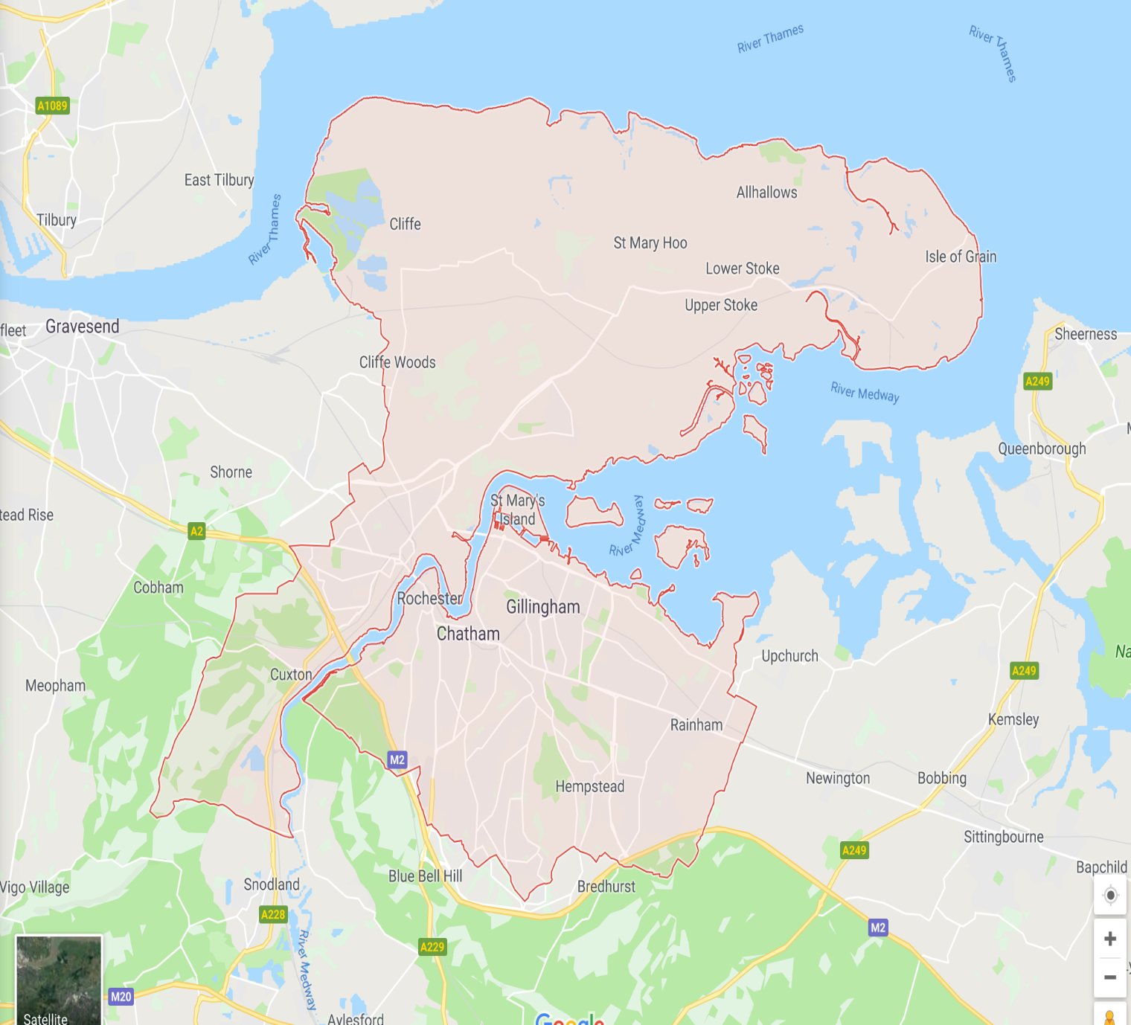

Appendix 2 – Emergency Procedure

The school’s emergency response to an incident is based on the following key factors:

- There is always a nominated emergency base contact for any visit (during school hours this is the office).
- This nominated base contact will either be an experienced member of the senior management team, or will be able to contact an experienced senior manager at all times.
- For activities that take place during normal school hours, the visit leadership team will be aware of any relevant medical information for all participants, including staff.
- For activities that take place outside normal school hours, the visit leadership team and the emergency contact/s will be aware of any relevant medical information and emergency contact information for all participants, including staff.
- The visit leader/s and the base contact/s know to request support from the local authority in the event that an incident overwhelms the establishment’s emergency response capability, involves serious injury or fatality, or where it is likely to attract media attention.
- For visits that take place outside the ‘extended learning locality’, the visit leader will carry either:
- An LA Emergency ‘Card’ (see EVOLVE Resources), or
- An OEAP National Guidance Emergency action card
- This Emergency Procedure is tested through both desk top exercises and periodic scenario calls from visit leaders.

This Policy will reviewed every two years or following any incident or “near miss”.

