**To all Parents/Carers of all Rowans’ pupils** 2nd September 2020

Dear Parent/Carer

# In addition to the recent letter sent to you I enclose some updates and clear guidelines for you and your son/daughter. We continue to follow the Government advice to ensure we give the safest welcome to our pupils.

# SAFE SPACE, CLEAN HANDS

The heart of our strategy to keep everyone safe will be increased hygiene, social distancing and reducing contact between groups in school.

* Each pupil will be part of a consistent class group and wider key stage 3 or 4 bubble. They must stay in these ‘bubbles’ and not move between groups.
* To help manage the safety of all Rowans’ members we have introduced additional measures that will allow pupils to move between lessons from safe space to safe space throughout the day within their class group, this will be achieved through increased cleaning processes

**CLEAN, USE, CLEAN**



Pupils will clean their hands with hand sanitiser as they enter the classroom.

The work area will be sanitised by the previous pupil sat at the desk at the end of the previous lesson

Pupils will engage in their lesson

At the end of the lesson the pupils will sanitise their work area.

Pupils will clean their hands with hand sanitiser as they leave the classroom.

Pupils will move to their next lesson and repeat the process.



The use of face coverings is optional, if pupils wish to wear them. Pupils MUST have face coverings on their person at all times. They MUST wear them when travelling on public transport or school transport and if they are asked to wear them by a member of staff around school, where social distancing may not be possible.

What face covering is permitted?

**Pupils are only permitted to wear a plain colour or simple patterned “face covering”** which covers the mouth and nose held in place by straps around the ears. See example below:

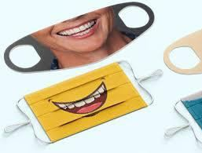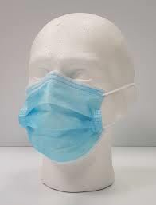

**No other type of face covering (e.g. scarf or bandana) is permitted**.

**What will happen if a pupil wears a face covering that is not permitted?**

You will be required to remove the face covering and hand it in to your form tutor until the end of the school day, you will be given a facemask by the school for that day. The expectation is that all pupils have their own face mask which they look after.

Pupils are expected to look after their own face covering and follow government guidance on wearing their face covering.

<https://www.gov.uk/government/publications/face-coverings-when-to-wear-one-and-how-to-make-your-own>

Whenever a pupil takes off their face covering it must be safely put away or disposed of in a lidded bin.

Stationery

All pupils will be given their own stationery and equipment for each lesson in a plastic ziplock wallet. There must be no sharing of equipment.

I hope that these updates are useful and I thank you for your continued support.

Kind regards



Mrs F May

Headteacher