Online Safety at The Rowans
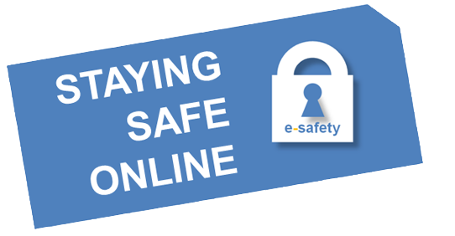

Information for Parents/Carers

At The Rowans we recognise that as a school we have a crucial role to play in educating our young people about the digital world that we live in. With social media readily available it is vital that we educate our young people about the threats the internet poses.

All staff have a full and active part to play in protecting and safeguarding the young adults in our care; our pupils’ welfare is our paramount concern.

- Every pupil at The Rowans signs a ‘network user agreement’ when they join the school. This agreement is a contract, where pupils agree to use the school network and internet appropriately for educational purpose.

- In KS3 all pupils study a Unit on E-Safety in ICT. Pupils are educated on the dangers the internet and social media pose, learn how to be a responsible internet user and report online threats.

- Pupils are taught and made aware that they should have a secure password, that includes lower and upper case letters, numbers and a symbol to prevent accounts being hacked; which does happen frequently.

- As a school we make clear to pupils that we will always contact parents/carers, social services and the police if pupils are found to have sent, possess or shared inappropriate images of themselves or other children under 18, even if they prove to be Googled images and the pupil is over 18 themselves. For help and support they have been advised to contact CEOP or ChildLine.

Having sexting photos or videos on a phone or computer of a child (anyone under 18) is against the law whatever age you are! Even if you are a child yourself. This is an offence under the Protection of Children Act 1978 and the Criminal Justice Act 1988

Important Organisations and Reporting a Problem

Here is material for parents and carers to access with the aim of better understanding the emotional and social pressures on your son or daughter.

CEOP and Think you know

The Child Exploitation and Online Protection Centre (CEOP) delivers a multi-agency service dedicated to tackling the abuse and exploitation of children in the real and the “e” world. CEOP was set up in April 2006 and has received over 50,000 reports of abuse to date. A key focus of CEOP is the Think U Know website and education strategy to teach young people, teachers and parents/carers about e-Safety and a “Report Abuse” button to report online abuse or suspicious behaviour and can be used by adults (parents/carers, professionals etc) and young people. There is also a suite of resources to support children with SEN including children with mild to severe learning difficulties, are blind or have a hearing impairment.

The VGT
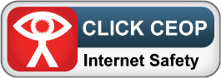

CEOP works as part of the Virtual Global Taskforce (VGT) which made up of law enforcement agencies from around the world www.virtualglobaltaskforce.com/ The report abuse button can be used to report inappropriate or potentially illegal activity towards a child. The “Report” button is available on many sites and any reports of abuse made will be answered 24 hours a day, 7 days a week from around the globe. If a child is ever in immediate danger, contact 999 for police assistance and follow usual school child protection procedures.

Childnet

‘Childnet International is a non-profit organisation working in partnership with others around the world to help make the internet a great and safe place for children.’

Know IT All for Parents: E-Safety

‘Know IT All for Parents is a unique interactive e-safety guide for parents and carers produced by Childnet International. It’s designed to really help you as a parent or carer keep up to date with how children are using the internet, and support them in using these new exciting services safely and responsibly.’
For more information on ‘E-Safety’, Please click here

